AI Agent Model Rental Marketplace
Detailed Implementation Plan — Rental-Only Model (No Backend, No Usage Metering, Pinata for Metadata)
Project Type | Scope | Repo Target | Stack
Blockchain Web Application | Rent-only marketplace for AI agent models | web3-dapp-starterkit (ChainFund base) | Next.js 14 + Solidity + Pinata, no backend

1. Project Overview & Goal
A decentralized marketplace where AI agent providers register their agent models and rent them out for a fixed price and a fixed time period (e.g. 7 or 30 days). Businesses / renters browse the marketplace, pay on-chain in a test ERC-20 token, and receive an on-chain rental record with a start time and an expiry. While the rental is active, the renter can see the agent’s access information. The actual AI processing stays entirely outside this project’s scope — you are not building or metering the agent, only the marketplace and rental/payment layer around it.
This is intentionally a rent-only product: no backend server, no usage tracking, no per-request metering, no access-token issuance. The on-chain rental record — who rented what, from when, until when — is the entire product. What the renter does with the agent afterward is between them and the provider, same as renting any other tool.

Goal
Build the rental + payment layer for AI agent models end-to-end inside the existing web3-dapp-starterkit repo — every file from the smart contracts to the last UI component — without adding any backend service or usage-tracking layer, and using Pinata for all off-chain agent metadata.

2. Actors
- Agent Provider: registers an AI agent model, sets a rental price and rental period, receives payment when rented, withdraws earnings.
- Renter (Business Customer): browses listed agents, pays to rent one for a fixed period, views access info while active, rates the provider after the rental.
- Marketplace Owner (contract deployer): sets the platform fee percentage, can pause a listing in case of abuse. No day-to-day admin approval queue in the MVP — listings go live immediately (kept simple since there is no backend to run a review workflow against).

3. System Architecture
Three layers only — frontend, smart contracts, and Pinata for metadata. No server sits between them at any point; the browser talks to the wallet, the chain, and Pinata directly.
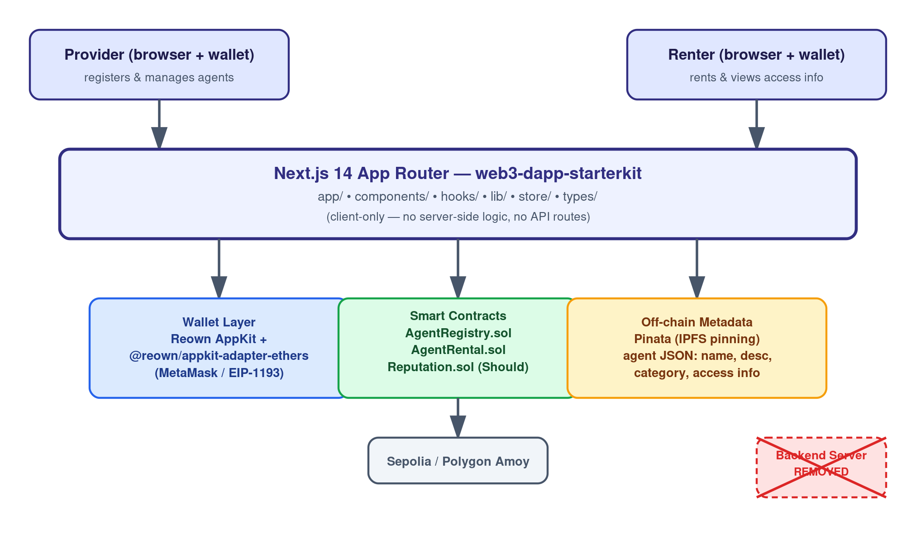
Figure 1 — System architecture: frontend talks directly to wallet, contracts, and Pinata; no backend.
- Frontend (Next.js 14, this repo): renders UI, reads contract state, builds transactions, calls Pinata’s REST API directly from the browser.
- Wallet layer: Reown AppKit + @reown/appkit-adapter-ethers, already wired in lib/appkit.ts — unchanged from the existing ChainFund setup.
- Smart contracts: AgentRegistry.sol, AgentRental.sol, and optionally Reputation.sol, deployed to Sepolia or Polygon Amoy — same deployment path already used for CrowdFunding.sol.
- Pinata: holds the off-chain JSON for each agent (name, description, category, sample I/O, access info). The contract only stores the resulting CID string (metadataURI).

4. Flow A — Agent Provider (2-in-1, part 1 of 2)
- Provider connects their wallet (Reown AppKit modal, same ConnectButton pattern already in this repo).
- Provider opens "Register Agent" and fills in: name, description, category, sample input/output, and the agent’s access info (endpoint URL or usage instructions).
- The frontend calls Pinata’s pinJSONToIPFS endpoint directly from the browser (no backend) with that metadata — Pinata returns an IpfsHash (CID).
- Provider sets pricePerPeriod (in the test ERC-20 token, 6 decimals — reusing the MockUSDT pattern already in contracts/MockUSDT.sol) and periodDuration (in days).
- Provider submits — this calls AgentRegistry.registerAgent(metadataURI, pricePerPeriod, periodDuration), where metadataURI = ipfs://<CID>. One transaction, signed in the wallet.
- The agent appears immediately in the public marketplace grid (no approval step in the MVP).
- Provider Dashboard shows: their listed agents, each agent’s active-rental count, and an accumulated-earnings balance.
- Provider can edit price or toggle an agent active/inactive (AgentRegistry.updateAgent) — changing price never affects renters who already paid, since each Rental snapshot is independent of the current listing price.
- Provider calls "Withdraw Earnings" (AgentRental.withdrawEarnings()) to pull the accumulated test-token balance to their wallet — a pull-payment pattern, so a bad renter transaction can never block the provider’s money.
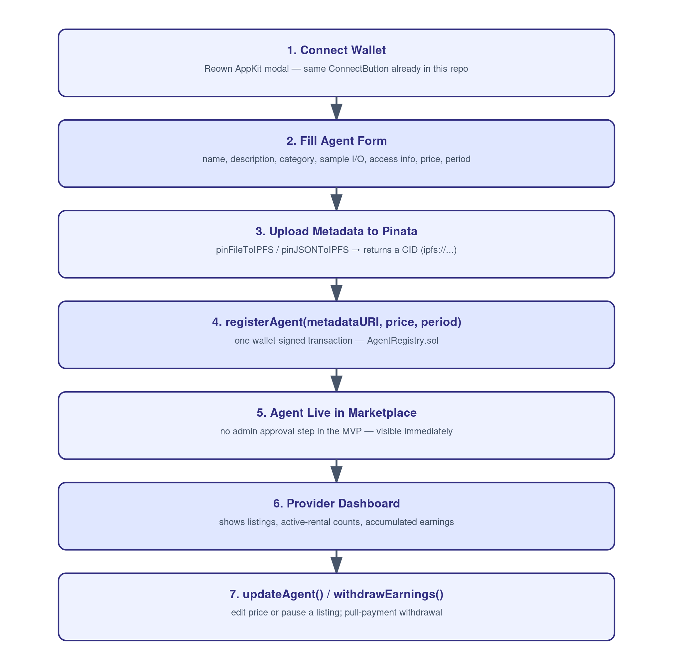
Figure 2 — Provider flow, step by step.

5. Flow B — Renter / Business Customer (2-in-1, part 2 of 2)
- Renter connects their wallet.
- Renter browses the Marketplace grid, filters by category / keyword, and opens an Agent Detail page.
- Agent Detail page shows: name, description, category, sample input/output, provider address, price per period, period length, and average rating — the on-chain fields read from the contract, the descriptive fields fetched straight from Pinata’s public gateway (https://gateway.pinata.cloud/ipfs/<CID>), no backend call.
- Renter clicks "Rent This Agent." If their test-token allowance is below the price, the UI first asks for an approve() transaction (ERC-20 pattern already used by useContribute.ts in this repo), then submits rentAgent(agentId).
- AgentRental.sol records a Rental(agentId, renter, startTime, expiry) and credits the provider’s withdrawable balance (minus the platform fee) — one or two wallet signatures total, no third-party step.
- Renter is redirected to "My Rentals," which lists every agent they have ever rented with a live Active / Expired badge computed from isRentalActive(renter, agentId).
- While a rental is Active, the renter can expand the card to reveal the agent’s access info (endpoint/instructions) pulled from Pinata — this reveal is a pure frontend check against the on-chain expiry, nothing is metered or logged past this point.
- Once a rental has started, the renter can submit a rating for that agent (Should-have — gated to one rating per completed rental so ratings cannot be spammed).
- Renter can renew anytime by rerunning step 4 — a new rental period simply starts from whichever is later: now, or the previous expiry (so renewing early does not waste unused time).
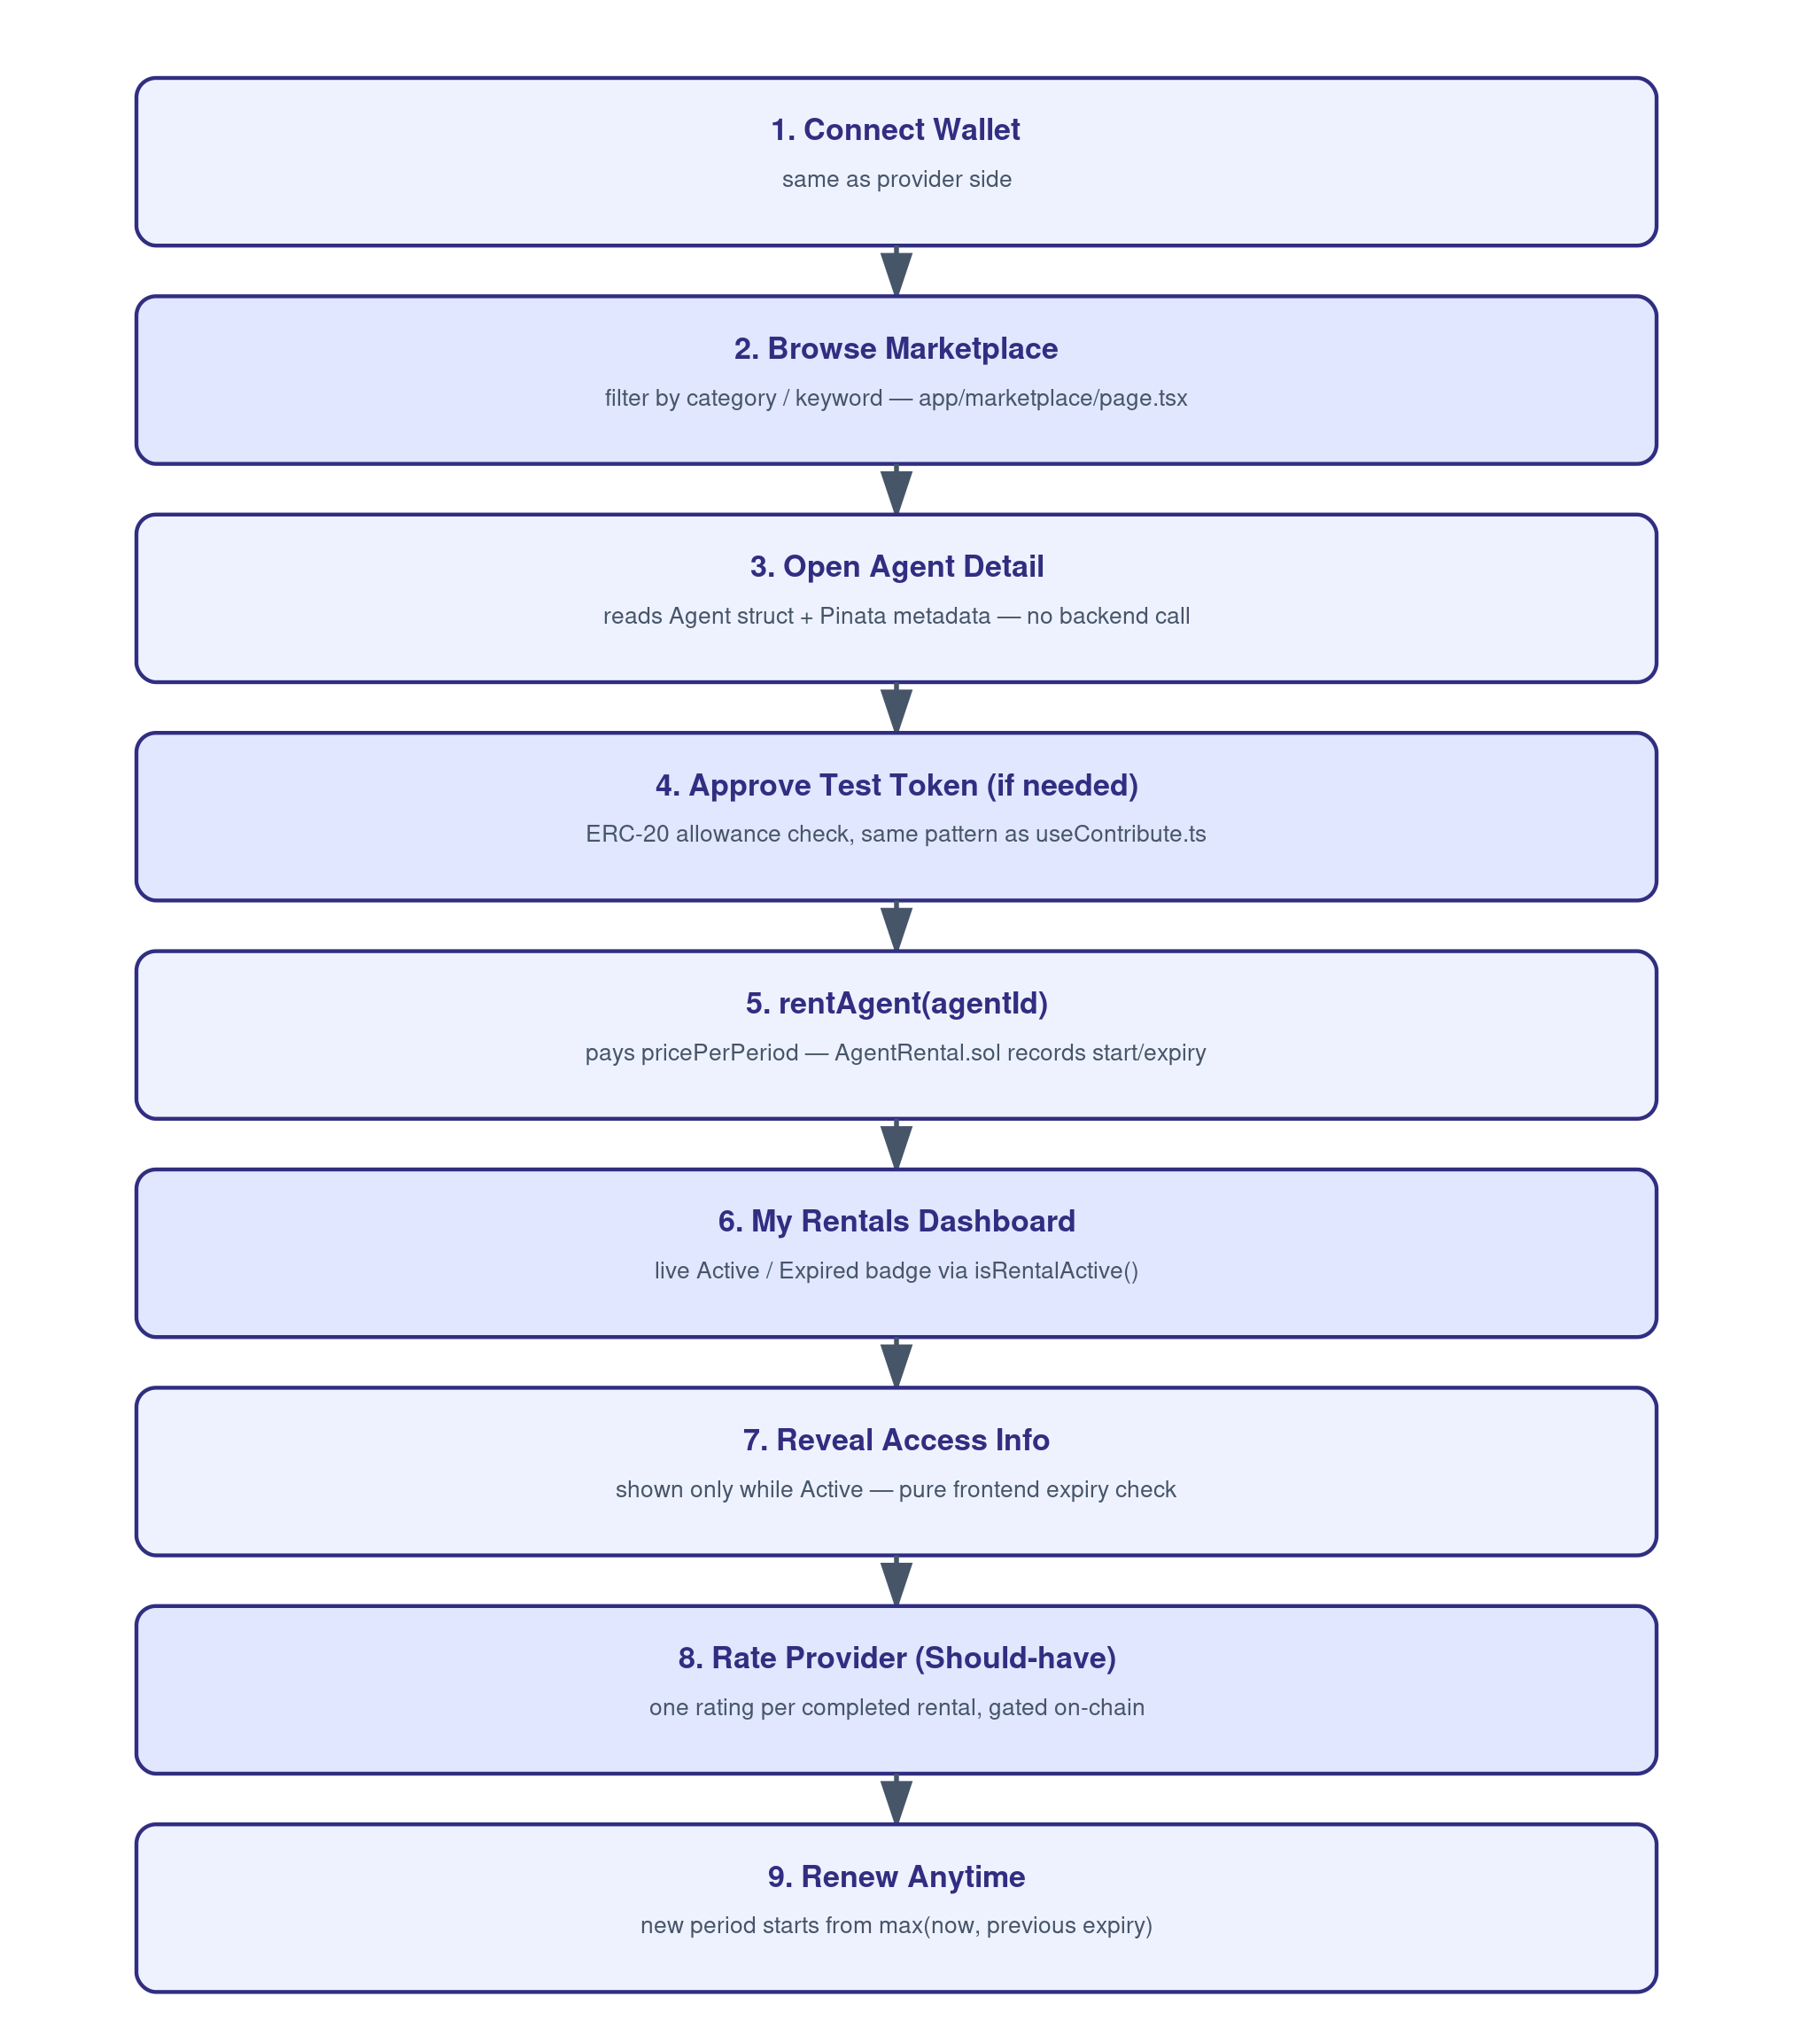
Figure 3 — Renter flow, step by step.

6. Application Screens → Repo Routes
Every screen below is a real Next.js App Router route inside app/.
# | Screen | Route (this repo) | Who
1 | Landing + wallet connect | app/page.tsx | Everyone
2 | Agent marketplace grid + filters | app/marketplace/page.tsx | Renter
3 | Agent detail + Rent action | app/marketplace/[id]/page.tsx | Renter
4 | My Rentals (active/expired + access reveal + rating) | app/rentals/page.tsx | Renter
5 | Provider Dashboard (listings + earnings + withdraw) | app/provider/page.tsx | Provider
6 | Register / Edit Agent form | app/provider/register/page.tsx | Provider
7 | Raw contract Read/Write tester (dev tool, reuses existing components) | app/dev/page.tsx | Dev only

6.1 Screen Layouts
Rough wireframes for the six user-facing screens, matched 1:1 to the routes above.
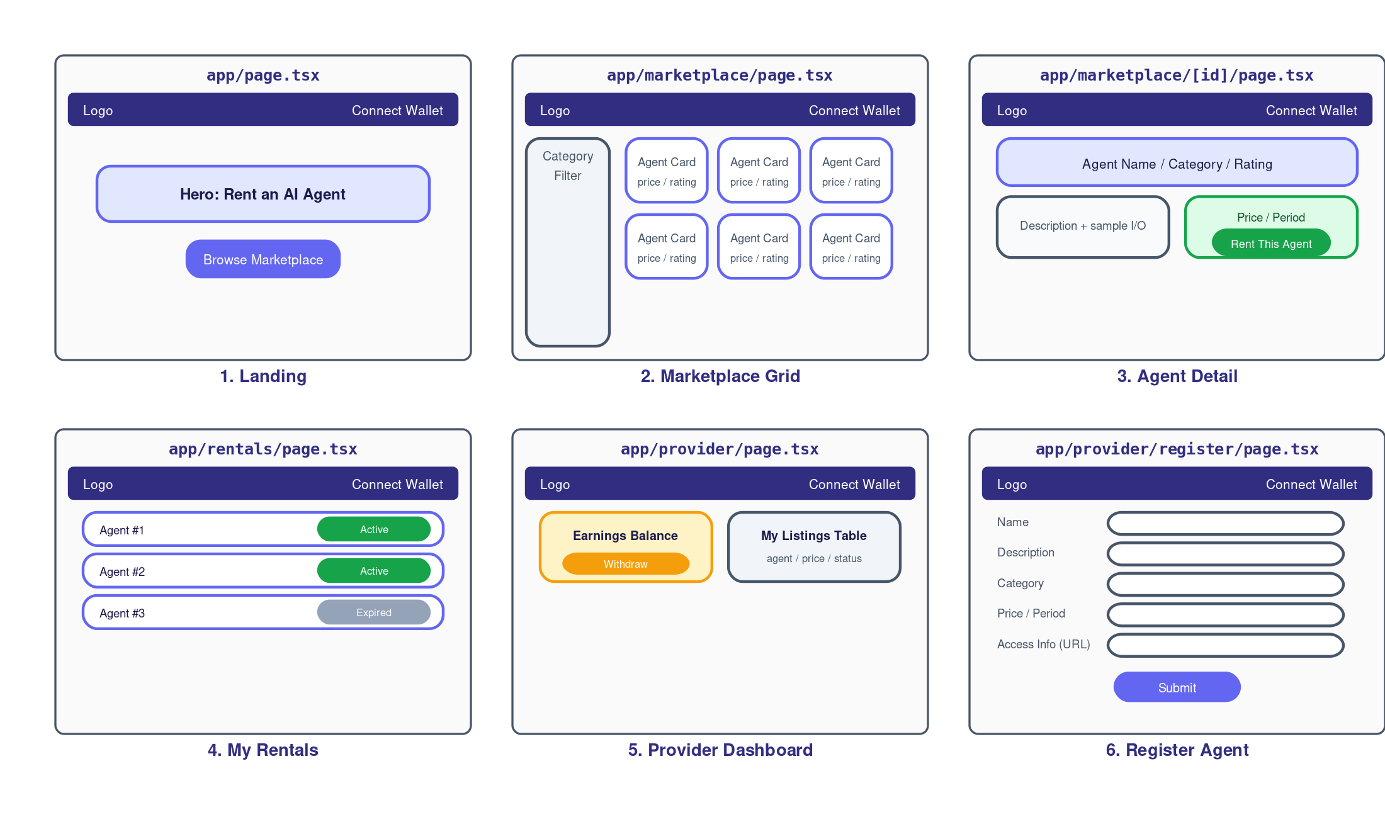
Figure 4 — Screen layout wireframes (Landing, Marketplace, Detail, My Rentals, Provider Dashboard, Register).

7. Data Structures
Four structures in total, three on-chain and one off-chain. This is the complete data model for the whole product — there is nothing else to model, which is the point of dropping the usage-tracking layer.
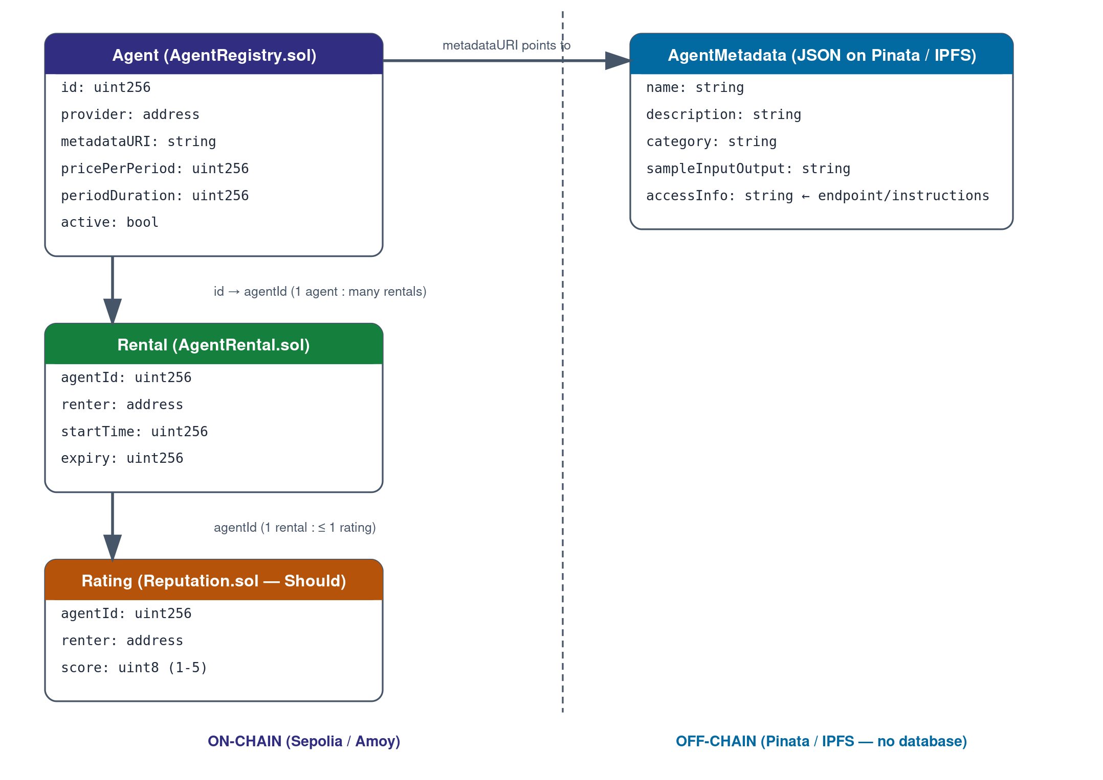
Figure 5 — Data structure / relationship diagram.

7.1 TypeScript mirror — types/index.ts
The frontend keeps a TypeScript interface per on-chain struct plus one for the off-chain metadata shape, so every hook and component is fully typed end-to-end.
export interface Agent {
id: bigint
provider: string
metadataURI: string // "ipfs://<CID>"
pricePerPeriod: bigint // test-token units, 6 decimals
periodDuration: bigint // seconds
active: boolean
}

export interface Rental {
agentId: bigint
renter: string
startTime: bigint
expiry: bigint
}

export interface AgentMetadata { // fetched from Pinata, not on-chain
name: string
description: string
category: string
sampleInputOutput?: string
accessInfo: string // endpoint / instructions, meaningful only while rental is active
}

export interface Rating { // Should-have
agentId: bigint
renter: string
score: number // 1-5
}

8. Smart Contracts (contracts/)
Three contracts, all Solidity ^0.8.20, deployed the same way the existing CrowdFunding.sol / MockUSDT.sol pair already is (Remix IDE → Sepolia or Polygon Amoy). No contract here ever stores request logs, usage counts, or API credentials — that data simply does not exist on-chain, by design.

8.1 contracts/AgentRegistry.sol
Owns the agent listings.
struct Agent {
uint256 id;
address provider;
string metadataURI;
uint256 pricePerPeriod;
uint256 periodDuration;
bool active;
}
Function | Type | Notes
registerAgent(string metadataURI, uint256 pricePerPeriod, uint256 periodDuration) | write | Anyone can call — creates a new Agent owned by msg.sender. Reverts if pricePerPeriod == 0 or periodDuration == 0.
updateAgent(uint256 id, uint256 pricePerPeriod, bool active) | write | onlyProvider(id) modifier — reverts if msg.sender != agents[id].provider.
getAgent(uint256 id) | view | Returns the full Agent struct.
getAgentCount() | view | Total agents ever registered.
Events: AgentRegistered(id, provider, metadataURI, pricePerPeriod, periodDuration), AgentUpdated(id, pricePerPeriod, active).

8.2 contracts/AgentRental.sol
The rental + payment contract. Combines what a split design would separate into ServicePlan / Payment / Subscription into one contract, since there is no usage layer left to justify splitting further. Takes the AgentRegistry address and the test-token address in its constructor, mirroring how CrowdFunding.sol takes the MockUSDT address today.
struct Rental {
uint256 agentId;
address renter;
uint256 startTime;
uint256 expiry;
}

mapping(uint256 => mapping(address => Rental)) public rentals; // agentId => renter => Rental
mapping(address => uint256) public providerBalance; // withdrawable earnings
uint256 public platformFeeBps = 500; // 5%, owner-adjustable
uint256 public platformBalance;
Function | Type | Notes
rentAgent(uint256 agentId) | write | Pulls pricePerPeriod via transferFrom (renter must approve first); new expiry = max(block.timestamp, currentExpiry) + periodDuration; credits providerBalance minus the fee, credits platformBalance with the fee.
isRentalActive(address renter, uint256 agentId) | view | block.timestamp < rentals[agentId][renter].expiry — the ONLY gate the frontend needs.
getRental(address renter, uint256 agentId) | view | Full Rental struct.
withdrawEarnings() | write | Pull-payment: transfers msg.sender’s accumulated providerBalance to their wallet, then zeroes it before the transfer (checks-effects-interactions).
setPlatformFeeBps(uint256 bps) | write | onlyOwner (OpenZeppelin Ownable). Capped at e.g. 2000 (20%) in the constructor invariant.
withdrawPlatformFee() | write | onlyOwner.
Events: AgentRented(agentId, renter, startTime, expiry, amount), EarningsWithdrawn(provider, amount), PlatformFeeChanged(bps).
Security building blocks to import from OpenZeppelin (see references, section 15): Ownable for the fee/owner controls, ReentrancyGuard on rentAgent and both withdraw functions. Follow checks-effects-interactions in every write function — update balances before calling transfer/transferFrom.

8.3 contracts/Reputation.sol — Should-have, not Must-have
Optional second-priority contract. Lets a renter submit a 1–5 rating for an agentId only if AgentRental.getRental(msg.sender, agentId).startTime != 0 (i.e. they actually rented it at least once) and only once per completed rental, to stop rating spam.
rateAgent(uint256 agentId, uint8 rating)
getAverageRating(uint256 agentId) view returns (uint256)

9. On-Chain vs Off-Chain Data
Layer | Holds | Where
On-chain | Agent id, provider address, price, period length, active flag, rental start/expiry, provider + platform balances, ratings | AgentRegistry.sol / AgentRental.sol / Reputation.sol
Off-chain (Pinata / IPFS only — no database) | Agent name, description, category, sample input/output, access info text | JSON pinned via Pinata, referenced by metadataURI
Explicitly does not exist | Request logs, usage counts, output history, access tokens, API secrets | Removed by design

10. Pinata / IPFS Integration Detail
Pinata is the only off-chain moving part in this project. It replaces what would otherwise be a database table of agent descriptions. All calls are made client-side, straight from the browser — there is no server-side proxy for Pinata either, consistent with the no-backend rule.

10.1 Environment variables
NEXT_PUBLIC_PINATA_JWT= # Pinata JWT (Account → API Keys → generate, scope: pinJSONToIPFS)
NEXT_PUBLIC_PINATA_GATEWAY=https://gateway.pinata.cloud/ipfs/
Known trade-off (client-side Pinata key):
Because the JWT is called with NEXT_PUBLIC_ and used directly from the browser, it is visible to anyone who inspects network requests. Scope the key to pinning only (not account-wide access) in the Pinata dashboard, and treat it as a rate-limit/abuse risk rather than a secrets risk — the same trade-off you accepted by removing the backend. If this becomes a real concern later, the fix is a one-endpoint backend proxy, which is explicitly out of scope for this plan.

10.2 lib/ipfs.ts (new)
const PINATA_JWT = process.env.NEXT_PUBLIC_PINATA_JWT ?? ''
const GATEWAY = process.env.NEXT_PUBLIC_PINATA_GATEWAY ?? 'https://gateway.pinata.cloud/ipfs/'

export async function uploadMetadata(metadata: AgentMetadata): Promise<string> {
const res = await fetch('https://api.pinata.cloud/pinning/pinJSONToIPFS', {
method: 'POST',
headers: {
'Content-Type': 'application/json',
Authorization: `Bearer ${PINATA_JWT}`,
},
body: JSON.stringify({ pinataContent: metadata }),
})
if (!res.ok) throw new Error('Pinata upload failed')
const { IpfsHash } = await res.json()
return `ipfs://${IpfsHash}`
}

export async function fetchMetadata(uri: string): Promise<AgentMetadata> {
const cid = uri.replace('ipfs://', '')
const res = await fetch(`${GATEWAY}${cid}`)
if (!res.ok) throw new Error('Failed to fetch agent metadata')
return res.json()
}

11. Full Repository Architecture (UI → Smart Contract, mapped into web3-dapp-starterkit)
This repo already carries a proven build pattern documented in WORKFLOW.md (from the ChainFund build): types/ → lib/ → store/ → hooks/ → components/ → app/, each layer depending only on the ones before it. This plan reuses that exact pattern and that exact build order, just pointed at agents/rentals instead of campaigns/contributions. hooks/, store/, and types/ do not exist in the repo yet (today it only has app/, components/, contracts/, lib/) — this plan is what creates them.

11.1 New / changed files, in build order
# | File | Purpose
1 | types/index.ts | Agent, Rental, AgentMetadata, Rating interfaces
2 | lib/utils.ts | cn, truncateAddress, formatToken, getTimeLeft (extend existing file)
3 | lib/validations.ts (new) | zod schemas: registerAgentSchema, rentSchema
4 | lib/ipfs.ts (new) | Pinata uploadMetadata(json), fetchMetadata(uri) — client-only, no backend (see section 10.2)
5 | lib/contract.ts | Replace CrowdFunding ABI with AgentRegistry + AgentRental ABIs and addresses (extend existing file)
6 | lib/mockData.ts (new) | MOCK_AGENTS, MOCK_RENTALS for the CONTRACT_ADDRESS-empty fallback mode
7 | lib/appkit.ts | Same createAppKit() call, update metadata.name/description (extend existing file)
8 | store/transactionStore.ts (new) | Reused as-is from WORKFLOW.md — isPending / message / txHash / refreshTrigger
9 | hooks/useWeb3.ts (new) | Reused as-is
10 | hooks/useAgents.ts (new) | Marketplace list, mock-fallback aware
11 | hooks/useAgent.ts (new) | Single agent by id, merges on-chain Agent + Pinata AgentMetadata
12 | hooks/useMyListings.ts (new) | Agents where provider === connected address
13 | hooks/useMyRentals.ts (new) | Renter’s rentals with live active/expired status
14 | hooks/useTokenBalance.ts (new) | Test-token balance + allowance, same shape as WORKFLOW.md
15 | hooks/useRegisterAgent.ts (new) | uploadMetadata() then registerAgent() write
16 | hooks/useUpdateAgent.ts (new) | updateAgent() write
17 | hooks/useRentAgent.ts (new) | approve() + rentAgent() 2-tx pattern, same shape as useContribute.ts (see section 11.2)
18 | hooks/useWithdrawEarnings.ts (new) | withdrawEarnings() write
19 | hooks/useRateAgent.ts (new, Should-have) | rateAgent() write
20 | components/TransactionLoadingScreen.tsx (new) | Reused as-is from WORKFLOW.md
21 | components/Providers.tsx | Reused as-is (already exists)
22 | app/layout.tsx | Update metadata title/description only
23 | components/PageWrapper.tsx (new) | Reused as-is
24 | components/Navbar.tsx (new) | Links: Marketplace / My Rentals / Provider Dashboard
25 | components/wallet/ConnectButton.tsx (new) | Split out of the existing WalletConnect.tsx
26 | components/agents/AgentCard.tsx, AgentGrid.tsx, AgentSkeleton.tsx, CategoryFilter.tsx (new) | Marketplace grid
27 | components/agents/AgentDetail.tsx (new) | Detail page body
28 | components/rent/RentModal.tsx, RentButton.tsx (new) | Approve + rent flow UI
29 | components/rentals/RentalCard.tsx, RentalStatusBadge.tsx (new) | My Rentals UI
30 | components/provider/RegisterAgentForm.tsx (new) | Register/edit form
31 | components/provider/MyListingsTable.tsx, EarningsCard.tsx, WithdrawButton.tsx (new) | Provider dashboard UI
32 | components/reputation/RatingStars.tsx, RatingForm.tsx (new, Should-have) | Rating UI
33 | app/page.tsx | Landing (extend existing file)
34 | app/marketplace/page.tsx (new) | Screen 2
35 | app/marketplace/[id]/page.tsx (new) | Screen 3
36 | app/rentals/page.tsx (new) | Screen 4
37 | app/provider/page.tsx (new) | Screen 5
38 | app/provider/register/page.tsx (new) | Screen 6
39 | app/dev/page.tsx (new) | Wraps existing components/contract/ReadFunctions.tsx + WriteFunctions.tsx, pointed at the new ABIs
40 | contracts/AgentRegistry.sol, AgentRental.sol, Reputation.sol (new) | Replace CrowdFunding.sol; keep MockUSDT.sol as the test payment token

11.2 hooks/useRentAgent.ts — reference implementation
Follows the exact 2-transaction shape already proven by hooks/useContribute.ts in this repo: check allowance, approve if needed, re-authorize the signer, then send the real transaction.
'use client'
import { getAgentRentalContract, getTestTokenContract, AGENT_RENTAL_ADDRESS, getTxUrl } from '@/lib/contract'
import { useWeb3 } from '@/hooks/useWeb3'
import { toast } from 'sonner'
import { getAuthorizedSigner } from '@/lib/authorizedSigner'
import { useTransactionStore } from '@/store/transactionStore'

export function useRentAgent() {
const { walletProvider, address, isConnected } = useWeb3()
const setPending = useTransactionStore((s) => s.setPending)
const triggerRefresh = useTransactionStore((s) => s.triggerRefresh)

const rentAgent = async (agentId: bigint, price: bigint): Promise<boolean> => {
if (!walletProvider || !address || !isConnected) return false
setPending(true, 'Waiting for signature in wallet...')
const { signer } = await getAuthorizedSigner(walletProvider, address)
const token = getTestTokenContract(signer)
let rental = getAgentRentalContract(signer)

const allowance = await token.allowance(address, AGENT_RENTAL_ADDRESS)
if ((allowance as bigint) < price) {
setPending(true, 'Approving token spend...')
const approveTx = await token.approve(AGENT_RENTAL_ADDRESS, price)
await approveTx.wait(1)
const fresh = await getAuthorizedSigner(walletProvider, address)
rental = getAgentRentalContract(fresh.signer)
}

setPending(true, 'Renting agent...')
const tx = await rental.rentAgent(agentId)
setPending(true, 'Confirming on blockchain...', tx.hash)
await tx.wait(1)
setPending(false)
triggerRefresh()
toast.success('Agent rented!', { action: { label: 'View Tx', onClick: () => window.open(getTxUrl(tx.hash), '_blank') } })
return true
}

const loading = useTransactionStore((s) => s.isPending)
return { rentAgent, loading }
}

12. Environment Variables (.env.local)
NEXT_PUBLIC_WALLETCONNECT_PROJECT_ID= # Reown/WalletConnect Cloud project ID (already have this)
NEXT_PUBLIC_AGENT_REGISTRY_ADDRESS= # AgentRegistry.sol deployed address
NEXT_PUBLIC_AGENT_RENTAL_ADDRESS= # AgentRental.sol deployed address
NEXT_PUBLIC_TEST_TOKEN_ADDRESS= # MockUSDT.sol address (already have this pattern)
NEXT_PUBLIC_CHAIN_ID=11155111 # or 80002 for Polygon Amoy
NEXT_PUBLIC_RPC_URL=https://rpc.sepolia.org
NEXT_PUBLIC_EXPLORER_URL=https://sepolia.etherscan.io
NEXT_PUBLIC_PINATA_JWT= # Pinata API JWT, pin-scope only
NEXT_PUBLIC_PINATA_GATEWAY=https://gateway.pinata.cloud/ipfs/
Leave NEXT_PUBLIC_AGENT_REGISTRY_ADDRESS / NEXT_PUBLIC_AGENT_RENTAL_ADDRESS empty during frontend-first development — every hook in section 11 falls back to lib/mockData.ts automatically, exactly like the existing CONTRACT_ADDRESS-empty mock mode.

13. Non-Functional Requirements
- Only an agent’s registered provider can update its price or active flag (enforced on-chain, not by the frontend).
- Rental gating (isRentalActive) is a public view function — anyone can check anyone’s rental status; no secret data lives in it.
- Provider earnings use pull-payment (withdrawEarnings), never push-payment, so one broken transfer can never lock the contract.
- rentAgent, withdrawEarnings, and withdrawPlatformFee must all be ReentrancyGuard-protected and follow checks-effects-interactions.
- Renewing a rental before expiry must extend from the current expiry, not from now, so a renter never loses paid time.
- The marketplace must clearly label test-token / testnet amounts as non-real value everywhere (same pattern the existing CrowdFunding UI already follows).
- A rating (Should-have) may only be submitted by a wallet that has an on-chain Rental record for that agent, capped at one rating per completed rental.
- Pinata JWT must be scoped to pinning only in the Pinata dashboard (see section 10.1) so a leaked client-side key cannot touch the account beyond uploads.
- Every write hook must show the wallet-signature → tx-hash → confirmed sequence via TransactionLoadingScreen, matching the existing UX pattern exactly.

14. Testing & Verification Checklist
Before calling any milestone done, walk through this list against a live testnet deployment — not just localhost with a mocked contract.
- Register two agents from two different wallets; confirm each shows up in the marketplace grid within one block.
- Rent an agent with insufficient allowance — confirm the UI requests approve() first, then rentAgent(), as two distinct signatures.
- Rent the same agent again before expiry — confirm the new expiry extends from the old expiry, not from "now."
- Confirm isRentalActive() flips to false the block after expiry, and the access-info panel in My Rentals disappears accordingly.
- Attempt updateAgent() from a wallet that is not the provider — confirm it reverts.
- Withdraw provider earnings twice in a row — confirm the second withdrawal reverts or pays zero, never double-pays.
- Submit a rating from a wallet with no rental record for that agent — confirm it reverts (once Reputation.sol is in scope).
- Kill the Pinata JWT / go offline — confirm the marketplace still renders on-chain fields (price, period, provider) even when the off-chain description fails to load, with a clear "metadata unavailable" fallback rather than a blank crash.
- Verify both contracts on the block explorer (Sepolia/Amoy) after deployment so source code is publicly readable.

15. Out of Scope for the MVP
- Training, hosting, or running the actual AI models — this project is the rental/marketplace layer only.
- Any backend server, database, request proxying, usage metering, or access-token issuance.
- True DRM / server-enforced access control on the agent’s endpoint (see the Pinata trade-off callout in section 10.1).
- Complex token economics, staking, or governance.
- Production-grade recurring billing or real-money payment rails.
- Full dispute-resolution / arbitration flow.
- Admin listing-review queue — listings go live immediately in the MVP.

16. Technology Stack
Component | Choice | Status in this repo
Frontend | Next.js 14, App Router, TypeScript | Already scaffolded
Styling / UI | Tailwind CSS + shadcn/ui | Already installed (button, card, badge, dialog, input, label, progress, skeleton, tooltip)
Wallet | @reown/appkit + @reown/appkit-adapter-ethers | Already wired (lib/appkit.ts)
Web3 library | ethers v6 | Already installed
State | Zustand (transaction status only) | To add: store/transactionStore.ts
Forms | React Hook Form + Zod | Already installed
Smart contracts | Solidity ^0.8.20 + OpenZeppelin (Ownable, ReentrancyGuard) | New: AgentRegistry.sol, AgentRental.sol, Reputation.sol
Payment token | Existing MockUSDT.sol test ERC-20 (6 decimals) | Reused as-is
Deployment | Remix IDE → Sepolia or Polygon Amoy testnet | Same as CrowdFunding.sol today
Metadata storage | Pinata (IPFS pinning, client-side REST calls) | New: lib/ipfs.ts
Backend | None | Intentionally absent
Database | None | Intentionally absent

17. Final Deliverables
- Working Next.js app connected to a blockchain testnet, fully inside web3-dapp-starterkit.
- Deployed and verified AgentRegistry.sol, AgentRental.sol, (and Reputation.sol if in scope) with source code.
- This implementation-plan document plus the WORKFLOW.md-style build recipe for the new files.
- Sample Pinata-hosted agent metadata for at least two demo agents.
- Git repository with setup instructions and .env.local template (section 12).

Success Criteria
The project is successful when a provider can register an agent, a renter can pay on-chain and receive an active rental, the renter can see the agent’s access info only while active, both sides can withdraw/verify their balances, and none of this requires a backend server or usage tracking of any kind.

18. Reference Reading, Categorized
Grouped by the part of the stack they support, so you can jump straight to what you’re building.

A. Solidity & Smart Contract Development
- Solidity language docs — https://docs.soliditylang.org/
- OpenZeppelin Contracts 5.x docs (Ownable, ReentrancyGuard, ERC-20 interface) — https://docs.openzeppelin.com/contracts/5.x/
- Hardhat docs (compiling/testing contracts locally before Remix deploy) — https://hardhat.org/docs
- Remix IDE docs (the same deploy path this repo already uses for CrowdFunding.sol) — https://remix-ide.readthedocs.io/

B. Wallet & Web3 Frontend Integration
- Reown AppKit docs (the wallet library already wired into lib/appkit.ts) — https://docs.reown.com/appkit/overview
- ethers.js v6 docs — https://docs.ethers.org/v6/
- EIP-1193 provider standard (what walletProvider implements) — https://eips.ethereum.org/EIPS/eip-1193

C. Next.js / Frontend Architecture
- Next.js App Router docs — https://nextjs.org/docs/app
- Tailwind CSS docs — https://tailwindcss.com/docs
- shadcn/ui component docs — https://ui.shadcn.com/docs
- Zustand docs (transactionStore pattern) — https://zustand.docs.pmnd.rs/
- React Hook Form + Zod resolver — https://react-hook-form.com/ and https://zod.dev/

D. Pinata / IPFS (off-chain metadata, replacing the backend/database)
- Pinata docs home — https://docs.pinata.cloud/
- Pinata pinJSONToIPFS API reference — https://docs.pinata.cloud/api-reference/endpoint/pin-json-to-ipfs
- Pinata API keys & JWT scoping guide — https://docs.pinata.cloud/account-management/api-keys
- IPFS concepts docs (background reading, not required to use Pinata) — https://docs.ipfs.tech/

E. Testnets & Verification
- Sepolia faucet — https://sepoliafaucet.com/
- Polygon Amoy faucet — https://faucet.polygon.technology/
- Etherscan contract verification guide — https://docs.etherscan.io/contract-verification

End of implementation plan.

